Managing stress during the Coronavirus (COVID-19) outbreak
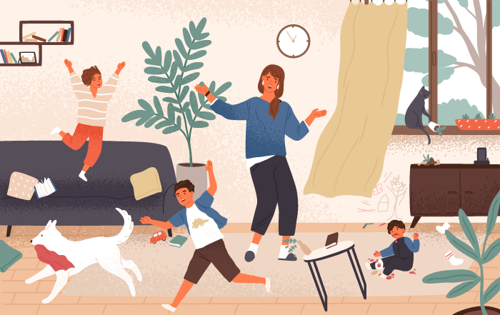
Social distancing because of Coronavirus (COVID-19) is the best thing we can do right now to decrease the risk of spreading the virus in our communities. But social distancing and self-isolation can be really stressful. The CDC says the following people may respond more strongly to the stress of a crisis such as this:
- Older people and people with chronic diseases that put them at higher risk
- Children and teens
- People who are helping with the response to COVID-19, like doctors and other health care providers or first responders
- People who have mental health conditions, including substance abuse
Even if you don’t fall into one of those categories, being cooped up in your house isn’t always easy. We have some recommendations for lowering your stress during this time of uncertainty.

Do virtual meetups or playdates.
Use whatever technology you have available (Skype, Zoom, FaceTime, etc.) to virtually meet up with those you love. If your kids are missing their friends from school or best friend from down the block, work with parents to arrange virtual playdates.
If communicating this way isn’t your thing, become pen pals with people. Most people love getting letters in the mail and the anticipation of the return letter will help pass the time.

Make “me” time.
“Me” time is important for everyone in your home to practice. Set aside time every day for your kids to do something for themselves or have quiet time in their rooms, and during this time, treat yourself to something that will help you relax.
Do 30 minutes of yoga, eat your favorite snack without having to share with your kids, or watch a new episode of a TV show—whatever it is that will help you unwind.

Cut yourself (and your kids) some slack.
When schedules and routines are turned upside down, everyone is off their game. You and your kids may feel cranky or frustrated, and there might be more crying than usual.
Remind yourself that some days are going to be harder than others, and don’t dwell on the things you could have gotten done or should have done differently. Instead, try to focus on the more positive moments throughout your day.

Go outside when possible.
Social distancing doesn’t require you to stay in your home 24 hours per day. If the weather is nice, get outside and play! Or just read a book on your porch while your kids play. Either way, your whole family will benefit from busting out of your home and burning some energy.

Limit your time on social media and watching the news.
This can be tough for some people because scrolling through social media is often seen as a way of relaxing. But the constant exposure to the worries over COVID-19 can be harmful.
Put a limit on how long you will spend on social media and how much of the news you’ll watch each day. Consider doing the same thing for your children. Their exposure to the news of COVID-19 can cause fear, worry, and stress, which can lead to irritability or acting out, unhealthy eating and sleep habits, excessive sadness, and difficulty with attention and concentration.

Check in with yourself and your partner about how you’re handling the stress as a parent.
It can be helpful to take a step back and evaluate how you’re handling the stress of COVID-19 and social distancing. Getting your partner’s feedback about whether you’re losing your cool often, raising your voice more than normal, or generally not acting like yourself is also helpful. Keeping open and honest communication is vital during this time.
If you find that the stress and worry of the situation is causing more irritation or anger with your child than usual, remind yourself of the following:
- Everyone in your family is experiencing some level of stress right now. No one is behaving as they would normally. If your child is acting up more than normal, try to figure out if there’s an underlying reason.
- Recognize that feelings of loneliness, boredom, fear, and anxiety are normal reactions to a stressful situation like this. You may need a time out yourself. Leave the room your kids are in for a few minutes, give yourself quiet time, or reach out to friends, family, or mental health professionals when you need a little extra help.
- Make sure any discipline tactics you’re using are fair and consistent. Discipline is more effective when parents know how to set and enforce limits, and when expected behaviors and punishments are based on their child’s age and level of development. Ultimately, you should teach your child how you would like them to act in the future.
- Communicate with your child about how you’re feeling. If you react in a way you wouldn’t normally, explain to them that you are struggling with sadness, frustration, or stress, and talk about how this situation is making you both feel.

Keep your routine (as much as possible).
With kids being out of school, and parents being out of work or working from home, routines are basically thrown out the window. But you can keep your family’s morning, mealtime, and bedtime routines consistent. This will give your kids a sense of consistency, and it will help you too.

Plan activities to pass the time.
Doing puzzles, taking classes online, or playing outside are all great ways to spend time during isolation. This is a great time to review old “Bill Nye the Science Guy” videos with your kids and recreate some of his experiments together!
If you usually get together with other families to play board games, cards, or watch movies, plan to still do those activities virtually. It might feel a bit odd at first, but it will help keep vital connections with others and help keep your mind busy.

This article was written and compiled by Anne Nielson, ARNP, DNP, CPNP-PC, Nurse Practitioner

